DATABASE MANAGEMENT SYSTEM

Introduction

Database Management system consists of a collection of interrelated data and a set of programs to access those data. The collection of data usually referred as database. Here a database holds information regarding an enterprise.

DBMS is a general-purpose software system that facilitates the processes defining, constructing and manipulating databases for various applications.

In simple words, DBMS is a computerized record keeping system that lets the user to perform various operations over the database.
The main objective of DBMS is to provide an environment that is both convenient and efficient to use in retrieving and storing data.

Data: Data refers to facts, symbols, events, entities, variable, names or any other, which has little meaning. Database that contains the facts like Employee Name, City, College etc, For Ex:

Krishna ECIL Hyderabad

The data may contain facts, text, images, sound and video segments.

Information: Processed data is known as Information.

Database: It is an organized collection of logically related data. The data are structured so as to be easily stored, manipulated and retrieved by users. For better retrieval and sorting, each record is usually organized as a set of data elements (facts). The items retrieved in answer to queries become information that can be used to make decisions.

For example a student may maintain a small database, which includes contacts like student number, name, address, phone no etc, in his computer.

Meta Data: Meta Data describes the structure of the primary database and it also describes the properties or characteristics of data. These properties may include data definitions, data structures, rules or constraints.
(Or)
Data about the data. The metadata describe the properties of data, but not include that data.

Database System Applications

Database System Application is an application program that is used to perform a series of database activities on behalf of database users.
The basic operations or activities are:
- CREATE
- READ
- UPDATE
- DELETE
Database applications are widely used. Here are some representative applications:

- Banking
- Airlines
- Universities
- Credit card Transactions
- Telecommunications
- Finance
- Sales
- Manufacturing
- Human Resources.

Traditional file Processing System

In the beginning of computer-based data processing, there were no databases. To be useful for business applications, computers must be able to store, manipulate, and retrieve large files of data. So, an organization's information was stored as groups of records in separate files. Computer file processing systems were developed for this purpose.

A file is a collection of records. A record in turn is a collection of several interrelated data items. In early days, user data is managed in terms of physical files in disks.

Disadvantages of File Processing System

The file processing system has several disadvantages. They are:

Data Redundancy: Data redundancy means duplication of data. As the data may be stored in several files, it may be repeated in multiple files, which leads to memory wastage and access cost. It in turn leads to data inconsistency, i.e., in various copies of the same data, one updating may lead to the necessary changes in all the remaining copies. It becomes tedious for the user.

Difficulty In Accessing Data: As no special application programs are available at that time, it becomes tedious for the user to access the data in this system. In other words we can say that the conventional file processing system does not allow us to access needed data in convenient and efficient manner.

Data Isolation: Because the data are scattered over the memory in terms of various files, and the files may be in various format, it is difficult to write new application programs to retrieve the necessary data.

Integrity Problems: Data validity is the most vital aspect in DBMS. To check the validity of the data, certain consistency constraints are to be imposed. Such constraints are difficult to be enforced in traditional file processing system. For example, salary of an employee should not be less than or equal to zero.

Atomicity Problem: In general a transaction is atomic, i.e., it must be either completely done or undone. As the computer system is an electronic device, it may subject to fail sometimes. If a failure occurred during the execution of a transaction, it may lead to data inconsistency. For example, consider bank transaction to transfer an amount of Rs.1000 from account A to account B. If a failure occurred in the middle, it may be possible that Rs.1000 may be removed from account A and was not credited to account B. Clearly, we say that while transferring the amount both credit and debit are to be done simultaneously.

Concurrent Access Anomalies: Concurrent access may be done to the same transactions in multi-user environments. It may again lead to inconsistency. For example, consider bank account A containing Rs.5000. If two customers withdraw funds (say Rs.1000 and Rs.2000 respectively) from the account at the same time, the transaction may leave incorrect data. The system may show the same balance Rs.5000 to both the customers and they may feel that they can withdraw a maximum amount of Rs.4500 leaving the remaining amount as minimum balance. It may lead to inconsistent data.

Security Problem: The entire database must not be available to all the database users. If the access is provided, improper and illegal operations may be performed over the database, which in turn leave inconsistent data. Hence certain security measures like individual user and their respective passwords are to be imposed over the database.

What is DBMS?

A Database Management System (DBMS) is a software package to facilitate the creation and maintenance of a computerized database. A Database System (DB) is a DBMS together with the data itself.
(Or)
A Database Management system consists of a collection of interrelated data and a set of programs to access those data. The collection of data usually referred as database. Here a database holds information regarding an enterprise.
(Or)
A Database Management System is a general-purpose software system that facilitates the processes defining, constructing and manipulating databases for various applications.
(Or)
A Database Management System is a computerized record keeping system that lets the user to perform various operations over the database.

Evaluation of Database Systems
DBMS were first introduced during the 1960’s. This was called “proof-off-concept” period in which the feasibility of managing vast amounts of data with DBMS was demonstrated.
The DBMS became a commercial reality in the 1970’s. The Hierarchical and network models were introduced in this decade. The relational model was first defined by E. F. Codd an IBM research fellow in 1970, and became commercially successful in the 1980’s.
Client/server computing and Internet applications became important in the 1990’s. Multimedia data, including graphics, sound, images, and video also became more common, and so object-oriented databases were introduced. Combination of relational and object-oriented databases known as object-relational databases are now available. In the future multidimensional data will become more important.

Database Approach

In traditional file processing each user defines and implements the files needed for specific application as part of the programming application. In database approach a single repository of data is maintained and accessed by various users. It emphasizes the integration and sharing of the data through out the organization.

Advantages of Database Approach

Program-Data Independence: The separation of data description (metadata) from the application programs that use the data leads to data independence. Data descriptions are stored in a central location called the repository. Organization's data can change and evolve without changing the application programs that process the data.

Minimal Data Redundancy: Traditionally, information systems were developed using a file-processing approach. Each application had its own files, and data was not shared among applications, resulting in a great deal of data redundancy, or repetition of the same data value.

The database approach was developed to minimize data redundancy by creating separate files for each entity. Files are referred to as tables, and a database is a collection of related tables. Data files are integrated into a single logical structure. While not completely eliminating redundancy, the designer can control the type and amount of redundancy.

Improved Data Consistency: Obtained by reducing redundancy. Updating data values is simplified, as each value is stored in one place only. Storage is not wasted.

Improved Data Sharing: Database is designed as a shared resource. Authorized users are granted permission to use the database, and provided with user views to facilitate this use.

Improved Productivity of Application Development: Reduction of the cost and time for developing new business applications. The programmer can concentrate on the specific functions required for the new application and DBMS provides a number of high-level productivity tools such as forms and report generators and high-level languages that automate some of the activities of database design and implementation.

Enforcement of Standards: Standards include naming conventions, data quality standards, and uniform procedures for accessing, updating, and protecting data.

Improved Data Accessibility and Responsiveness: End users without programming experience can retrieve and display data (using SQL).

Reduced Program Maintenance: Data are independent of the application programs that use them, and either one can be changed without a change in the other.

Data Integrity: The term data integrity refers to the degree to which data is accurate and reliable. Integrity Constraints are rules that all data must follow. For example if month is a field, then a number greater than 12 is invalid. Similar examples are number of days in a month, number of hours in a day, etc. Other invalid values could be pay rates, temperatures (too high or too low) etc.
.

Disadvantages of Database Approach

New, Specialized Personnel: New individuals need to be hired and/or trained, and frequently retrained or upgraded to implement databases.
Installation, Management Cost and Complexity: A multi-user DBMS is a large and complex suite of software that has a high initial cost and require a staff of trained personnel to install and operate. A substantial annual maintenance and support costs are needed. Hardware and Data Communications systems may need upgrading. Security software is often required to ensure proper concurrent of shared data.
Conversion Costs: Old file processing system converted to modern database technology will cost money and time.
Need for Explicit Backup and Recovery: Data may be damaged or destroyed, due to hardware failure, physical damage caused by fires or floods, and software or human errors. A backup, or copy, must be made periodically. DBMS’s include backup routines or rely on system utilities. Recovery is replacing the damaged database with good backup. Users have to renter data of any transactions lost since the last backup.
Organizational Conflict: Conflicts on data definitions, data formats and coding, rights to update shared data, and associated issues are difficult to resolve.
Security: In addition to User ID and password, specific privileges can be assigned to each user, defining that user's access to the data. Read-only privilege permits that user only to look at the data; no changes are allowed. Update privilege allows the user to make changes to the data. DBMS has privileges at the field level; a user may be able to change some fields, just look at others, and not even see some fields.

View of Data or levels of Data Abstraction

A Database is a collection of interrelated files and set of programs that allow users to access and modify these files. The main objective of three-schema architecture is to separate database from application programs.

A commonly used view of data approach is the three-level architecture suggested by ANSI/SPARC (American National Standards Institute/Standards Planning and Requirements Committee). Under this approach, a database is considered as containing data about an enterprise.

The three levels of the architecture are three different views of the data. The design of each such level is considered as a schema and hence the whole design is referred as three-schema architecture. With the three schemas, program data independency can corresponding operation independency can be achieved. This process is also referred to as data abstraction.

- Internal Level or Internal Schema or Physical Level.
- Conceptual Level or Conceptual Schema or Logical Level.
- External Level or External Schema or View Level.

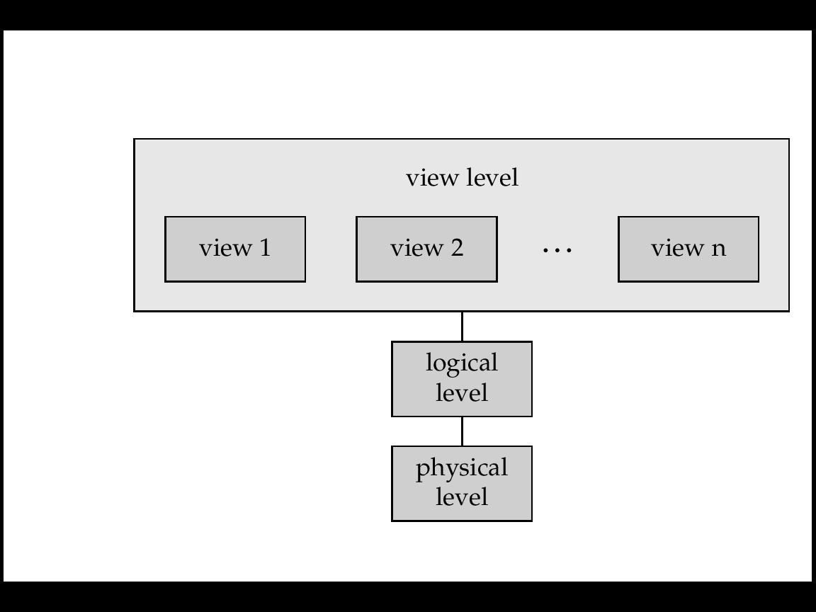
Three Levels Of Data Abstraction

The three level database architecture allows a clear separation of the information meaning (conceptual view) from the external data representation and from the physical data structure layout.

External Schema: The highest level of data abstraction is nothing but external schema. It describes only a part of the entire database. It is basically presentation level. Several users of the database have their own view of data. Each has a separate design of approach. In general, the end users and even the application programmers are only interested in a subset of the database. For example, a department head may only be interested in the departmental finances and student enrolments but not the library information. The librarian would not be expected to have any interest in the information about academic staff. The payroll office would have no interest in student enrolments.

Logical or Conceptual Schema: The conceptual view is the information model of the enterprise and contains the view of the whole enterprise without any concern for the physical implementation. In this level, we describe what data are to be stored and what relationships exist among the data. The database administrators use this level of abstraction.
Internal Schema: The lowest level of data abstraction describes how the data is actually stored. In this level, complex data structures of low level are described in detail. In other words, the internal view is the view about the actual physical storage of data. It tells us what data is stored in the database and how.

Data Models

A data model is tells about the underlying structure of a database. It is a collection of conceptual tools like describing the data, data relationships, data semantics and consistency constraints. The various data models that have been proposed fall into three categories:
- Object based Data Model.
- Record based Data Model.
- Semi Structured Data Model
- Physical Data Model.
Object based data model: This data model is used in describing data at the logical and view levels and it specify fairly flexible structures. There is another classification of in this model:
- Entity-Relationship model.
- Object- oriented data model.
Entity Relationship data model: The entity – relationship data model is a logical representation of the data for an organization or for a business area or the entity-relationship (E-R) data model is based on a perception of real world that consists of a collection of basic objects called entities and relationships among these objects. An entity is a thing or object or physical construct. An employee, a student, a product are considered as entities. A relationship is an association of several entities.

Object Oriented Data model: Like E-R data model, the object oriented data model is also based on a collection of objects. An object is an instance, which holds a set of values within itself. An object may contain the body of the operations that work on the data. The bodies are known to be methods. Unlike E-R data model, each object has its own unique identity, independent of the values that it contains.

Record Based Data model: Record based data models are also used for describing data at logical level and view level as well. These data models are used to specify the overall structure of the database and to provide a higher level implementation. Record based data models, as they are named, maintain fixed format records of several types. The three widely acceptable record based data models are:
- Relational data model.
- Hierarchical data model.
- Network data model.

Relational data model: The relational data model uses the concept of relations to represent each and every file of a system. Relations are nothing but two-dimensional arrays (or tables) that represent data in a most efficient way or a relational data model are a collection of tables and associated relationships among those data. Each table is a combination of multiple rows and columns, and each column has unique name. In other words a relational data model is exactly, a way of looking at data i.e., creation and manipulation of data. In another way, we can say that a database management system that manages information in terms of tables is nothing but RDBMS. The relational data model is concerned with three aspects:
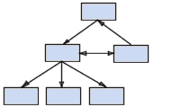
- Data structure.
- Data integrity.
- Data manipulation.

Network data model: Data in network data model is represented by a collection of records and relationships among data are represented by links which are viewed as pointers. Literally the records are represented as graphs.

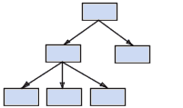
Hierarchical data model: The hierarchical data model is similar to network data model in the sense that data and relationships among the data are represented as records and links respectively. In this data model, unlike network data model, records are organized in terms of tree structure.

Physical Data models: The physical data model is used to describe data at lowest level. Unlike other data models, physical data models are very less in use. Two widely known ones are:
- Unifying data model.
- Frame-memory data model.
Semi-structured Data Models: The semi-structured data model permits the specification of data where individual data items of the same type may have different sets of attributes. This is quiet against to the above mentioned data models. The XML (Extensible Markup Language) is widely used to represent semi-structured data.

Database Users and Administrators

A primary goal of database system is to retrieve information from and store new information in the database. People who work with a database can be categorized as database users or database administrators.

Database users

There are four different types of database-system users, differentiated by the way they expect to interact with the system. Different types of user interfaces have been defined for different types of users.
Naïve Users are unsophisticated users who interact with the system by invoking one of the application programs that have been written previously. For example a bank teller who transfers Rs. 500 from account A to account B invokes a program called transfer. People, who wish to check their balance over the worldwide web, are the other example for naïve users. Naïve users use the forms as their user interfaces and can read the reports.
Application Programmers are computer professionals who write application programs. Application programmers can choose from many tools to develop user interfaces. RAD (Rapid Application Development) Tools are the tools that enable an application programmer to construct forms and reports with minimal programming effort.
Sophisticated Users interact with the system without writing programs. Instead, they form their requests in a database query language. They submit each query to the query processor. The job of a query processor is to bread down the DML statements in to instructions so that they can be understood by the storage manager. Analysts who submit queries to explore or extract data in the database will fall in this category.
Specialized Users are sophisticated users who write specialized database applications that do not fit into the traditional data processing framework. CAD systems, knowledge based expert systems are the examples for such specialized database applications.
End Users:
Persons who add, delete, and modify data in the database and who request and receive information from it.

DBA
The database administrator (DBA) is the person (or group of people) responsible for overall control of the database system. The DBA would normally have a large number of tasks related to maintaining and managing the database. The DBA's responsibilities include the following:

- Schema Definition. The DBA creates the original database schema by executing a set of data definition statements in the DDL.
- Storage Structure and access-method definitions.
- Schema and physical organization modification. The DBA carries out changes to the schema and physical organization to reflect the changing needs of the organization, or to alter the physical organization to improve performance.
- Granting of authorization for data access. By granting different types of authorization, the database administrator can regulate which parts of the database the users can access. The authorization information is kept in a special system structure that the database system consults whenever someone attempts to access the data in the system.
- Routine maintenance. Examples of the database administrator’s routine maintenance activities are:
    - Periodically backup the database, either on to tapes or on to remote servers, to prevent loss of data incase of natural calamities like flooding.

    - Ensuring that enough disk space is available for normal operations, and upgrading disk space as required.

    - Monitoring jobs running on the database and ensuring that performance is not degraded by very expensive tasks submitted by some users.

Database System Structure
A database system is partitioned into modules that deal with each of the responsibilities of the overall system. The functional components of a database system can be broadly divided into the storage manager ad the query processor components. Storage manager is a program module that provides the interface between the low-level data stored in the database and the application programs and queries submitted to the system. The query processor helps the database system in simplifying and facilitate to access data.
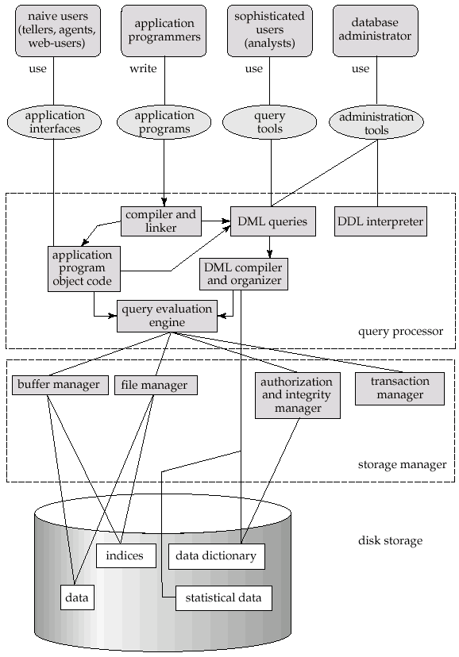

E-R DATA MODEL

Introduction

The entity –relationship data model is a logical representation of the data for an organization or for a business area or The entity-relationship (E-R) data model is based on a perception of real world that consists of a collection of basic objects called entities and relationships among these objects.
An entity is a thing or object or physical construct. An employee, a student, a product are considered as entities. A relationship is an association of several entities.

Entity Sets
An entity is a person, place, object event or concept in the user environment about which the organization wishes to maintain data. (Or) The Entity-Relationship (ER) model, a high-level data model that is useful in developing a conceptual design for a database. (Or) An entity is an object that exists and is distinguishable from other objects. For instance, “Krishna” with Emp-ID V053 is an entity, as he can be uniquely identified as one particular employee in the organization.

Person: EMPLOYEE, STUDENT, PATIENT
Concept: ACCOUNT, COURSE, WORK CENTRE
The overall logical structure of database can be expressed graphically by an E-R diagram, which is built up from the following components:

Rectangles - To represent entities.
Ellipses - To represent attributes.
Diamonds - To represent relationships among entities.
Lines - To link attributes to entities.

Basic E-R notations
Entity
Attribute
Weak Entity

Associative entity relationship identifying relationship

Multi-valued attribute Derived attribute

Entities are the principal data object about which information is to be collected. Entities are usually recognizable concepts, either concrete or abstract, such as person, places, things, or events, which have relevance to the database.
Entities are classified as independent or dependent. An independent entity is one that does not rely on another for identification. A dependent entity is one that relies on another for identification.
An entity occurrence (also called an instance) is an individual occurrence of an entity. An occurrence is analogous to a row in the relational table.
Entity sets is a set of entities of the same type that share the same properties, or attributes. The set of all persons who are students at a given Institute can be defined as the entity set student.
The entity-relationship model is based on a perception of the world as consisting of a collection of basic objects (entities) and relationships among these objects.
Attribute:
Attributes are also termed Properties. Attributes or Properties are characteristics of an entity. Examples: CustomerNumber, OrderNumber, OrderDate, ProductNumber.
Attributes describe the entity of which they are associated. A particular instance of an attribute is a value.
The domain of an attribute is the collection of all possible values an attribute can have. The domain of Name is a character string.
In the example shown below, attribute names are shown as a combination of upper and lower case characters inside bubbles. Here customer is an entity. Customer Name, Customer Number and Phone Number are properties or attributes.
CUSTOMER
Customer Number
Customer Name
Phone
Number

The following attribute types, as used in the E-R model can characterize an attribute.

Simple Attributes: An Attribute is one that cannot be divided into sub parts. (Or) A simple attribute is one component that is atomic.

Composite Attribute: A composite attribute has multiple components, each of which is atomic or composite. (Or) An attribute can be broken down into component parts. The most common example is Name, which can usually be broken down into the First Name, Middle Name, and Last Name.

Name
Middle Name
Last Name
First Name

Another example is the attribute, Address, which can be broken down into Street, City, State, and ZipCode.

Single Valued Attributes: An entity attribute that holds exactly one value is a single-valued attribute.
Multi-valued Attributes: A multi-valued attribute is an attribute that may take on more than one value for a given entity instance. For example, the employee entity type in given picture has an attribute name Skill, whose values record the skill (or skills) for that employee.
Employee
Dependent

Derived Attributes: An attribute whose values can be calculated from related attribute values. (Or) A derived attribute can be obtained from other attributes or related entities
Person
Age
Date of birth

Relationships

A relationship type is a set of associations among entity types.
For example, the student entity type is related to the team entity type because each student is a member of a team. In this case, a relationship or relationship instance is an ordered pair of a specific student and the student's particular Computers team, such as (Hanuman, Computers), where computers 8261 is Hanuman’s team number.

We arrange the diagram so that the relationship reads from left to right, "a student is a member of a team". Alternatively, we can arrange the components from top to bottom.
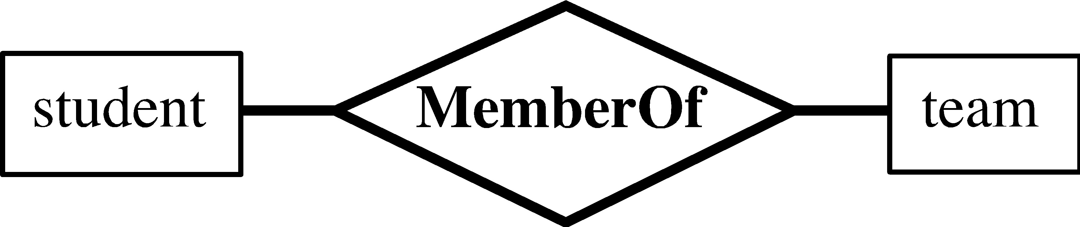
ER diagram notation for relationship type, MemberOf

A relationship set is a set of relationships of the same type.
Formally it is a mathematical relation on (possibly non-distinct) sets.
If are entity sets, then a relationship set R is a subset of
, Where is a relationship.
For example, consider the two entity sets customer and account. We define the relationship CustAcct to denote the association between customers and their accounts. This is a binary relationship set. Going back to our formal definition, the relationship set CustAcct is a subset of all the possible customer and account pairings.
This is a binary relationship. Occasionally there are relationships involving more than two entity sets.
The role of an entity is the function it plays in a relationship. For example, the relationship works-for could be ordered pairs of employee entities. The first employee takes the role of manager, and the second one will take the role of worker.
A relationship may also have descriptive attributes. For example, date (last date of account access) could be an attribute of the CustAcct relationship set.

Cardinality Constraint

An E-R scheme may define certain constraints to which the contents of a database must conform.
A mapping cardinality is a data constraint that specifies how many entities an entity can be related to in a relationship set.
Example: A student can only work on two projects, the number of students that work on one project is not limited.
A binary relationship set is a relationship set on two entity sets. Mapping cardinalities on binary relationship sets are simplest.
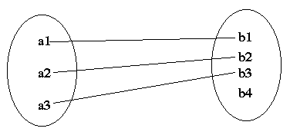
Consider a binary relationship set R on entity sets A and B. There are four possible mapping cardinalities in this case:
One-to-One:
An entity in A is related to at most one entity in B, and an entity in B is related to at most one entity in A.

One-to-Many:
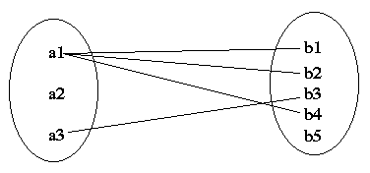
An entity in A is related to any number of entities in B, but an entity in B is related to at most one entity in A.

Many-to-One:
An entity in A is related to at most one entity in B, but an entity in B is related to any number of entities in A.

Many-to-Many:
An entity in A is related to any number of entities in B, but an entity in B is related to any number of entities in A.
The appropriate mapping cardinality for a particular relationship set depends on the real world being modeled.

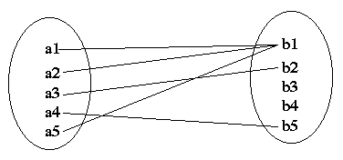
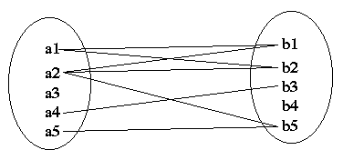

E-R Diagrams

The following are different types of E-R diagrams:
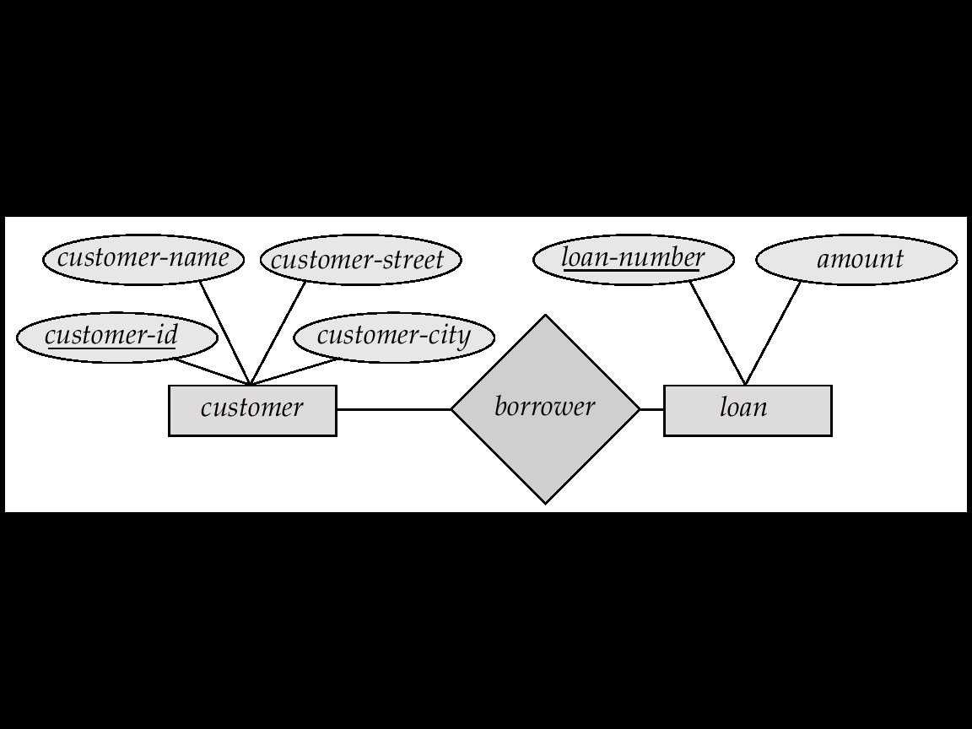

E-R Diagram corresponding to customer and loan
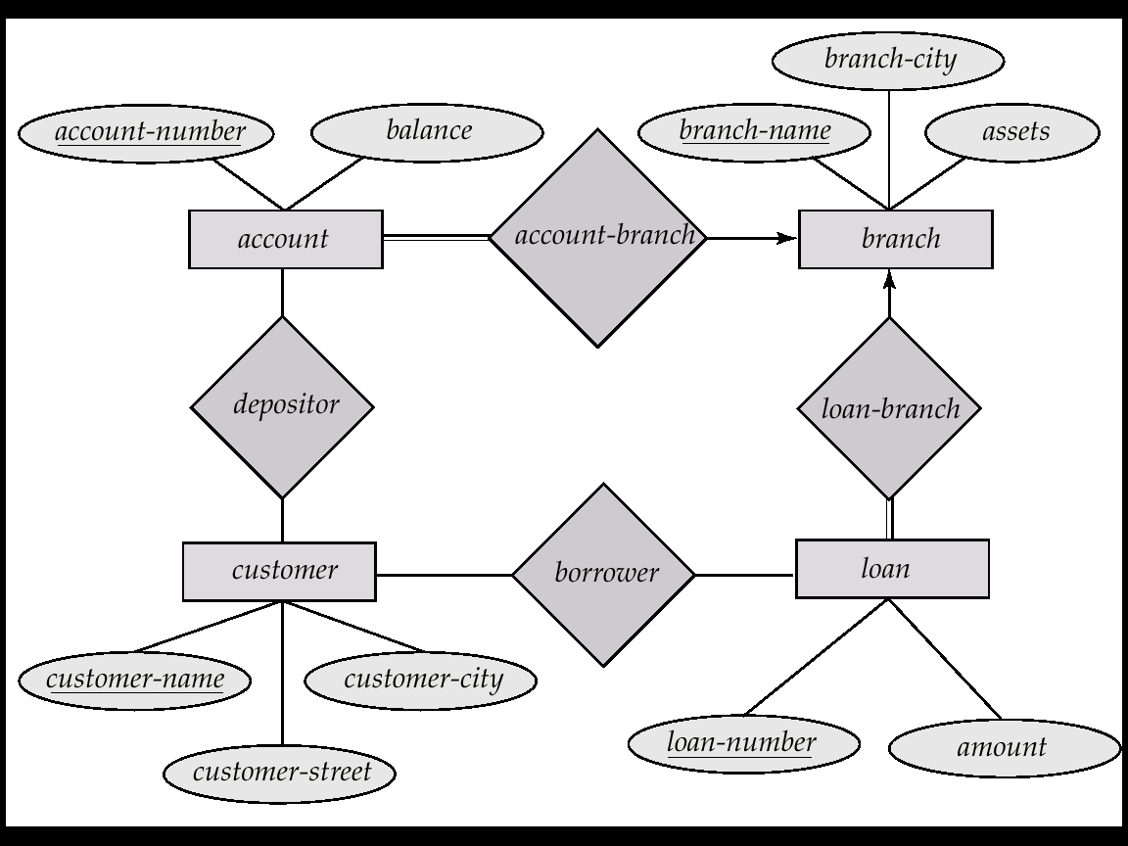

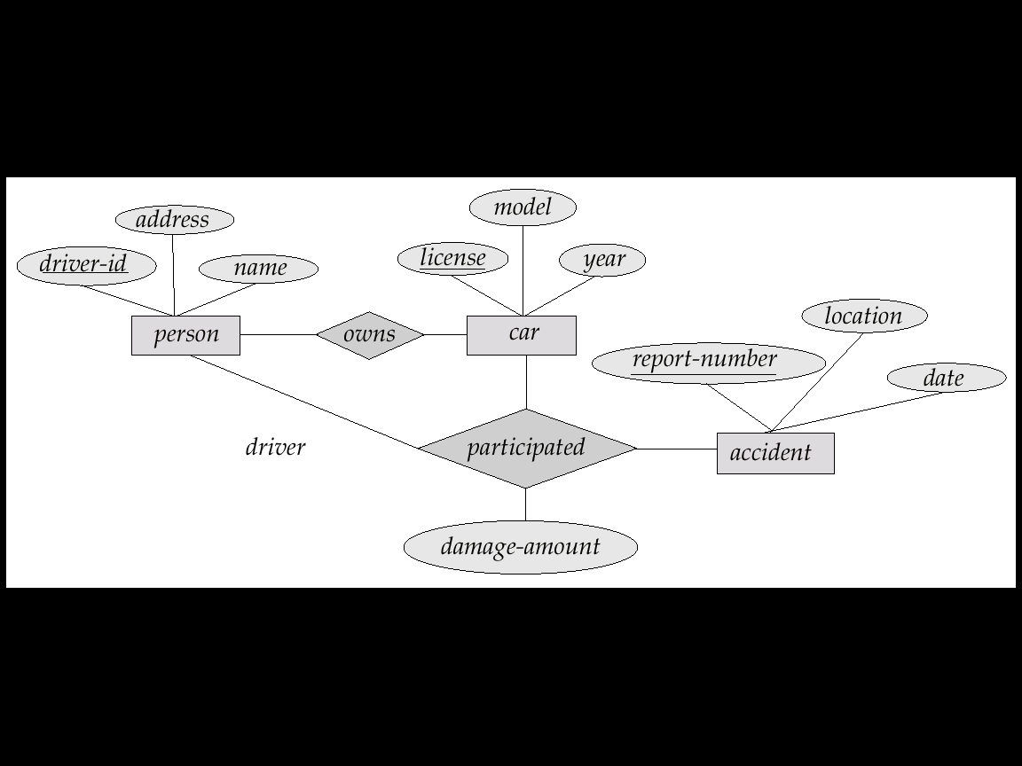

E-R Diagram with multiple entities

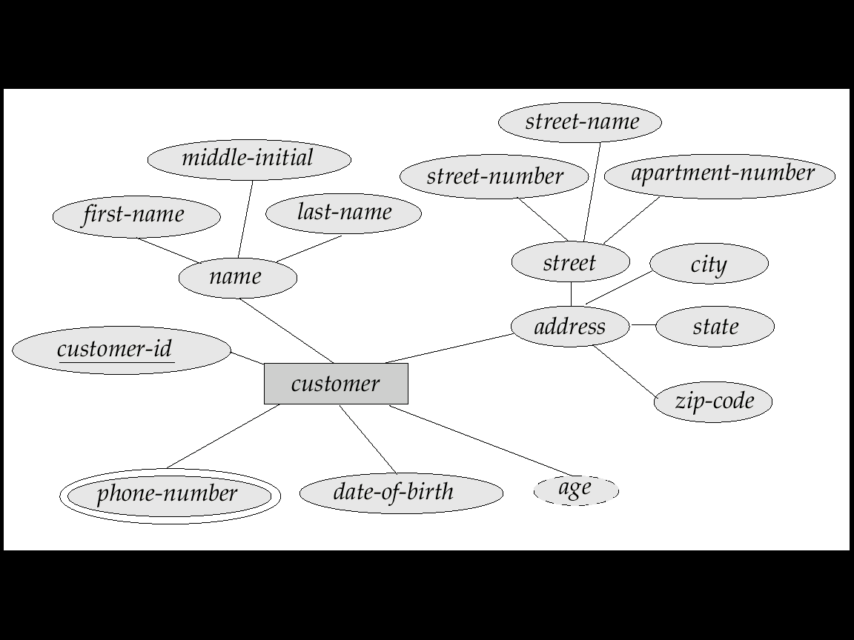

E-R Diagram with all types of attributes

Relationship with Attributes

The other category of relationship follows:

- Unary Relationships
- Binary Relationships
- Ternary Relationships

Unary Relationship: An entity that holds a relation with the entity of same set.
Binary Relationship: A relationship that holds between two entities is a binary relationship.
Ternary Relationship: A relationship that can be hold among three entities is a ternary relationship.

Person
Marries

Unary Relationship

Binary Relationship
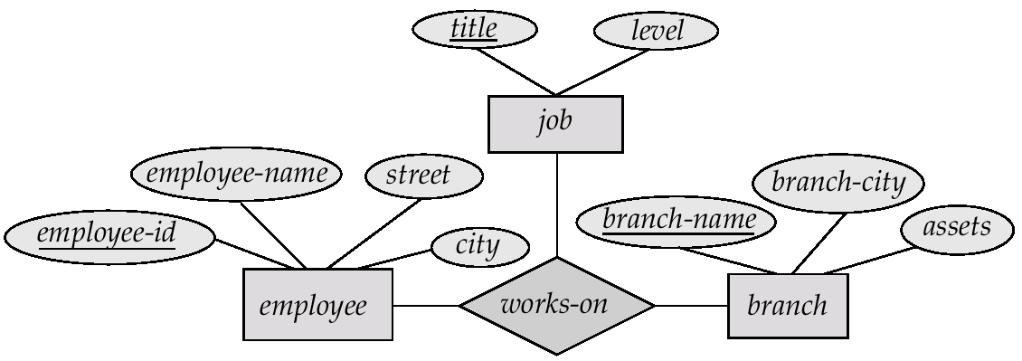

Ternary Relationship

Weak Entity Sets: An entity set may not have sufficient attributes to form a primary key. Such an entity set is termed a weak entity set. An entity set that has a primary key is termed as Strong Entity Set. For example:
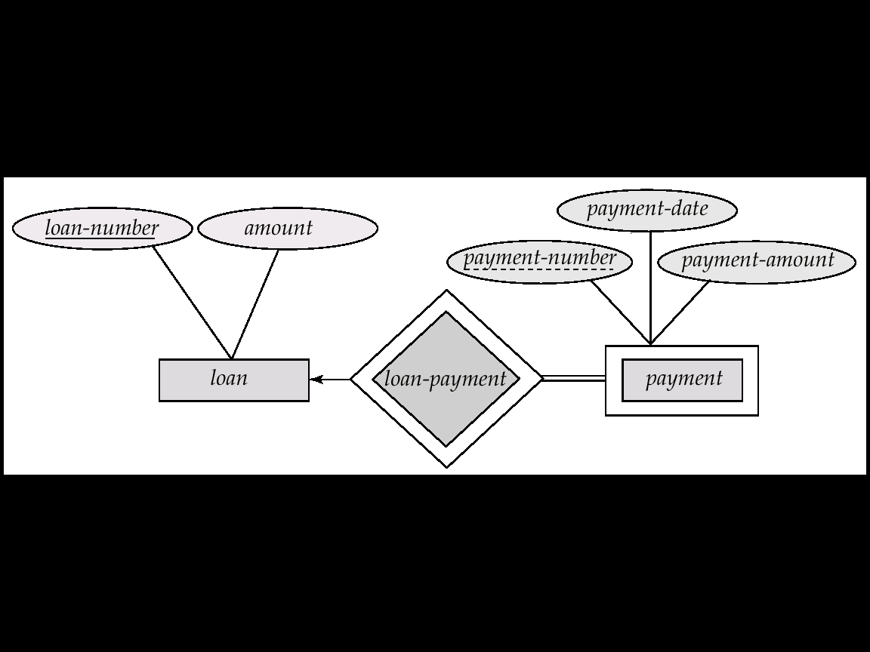

Extended E-R Diagrams

Basic Concept

Although the basic concepts can model most database features, some aspects of a database may be more aptly expressed by certain extensions to the basic E-R model. In this section of lesson, we discuss extended E-R features of specialization, generalization, higher level and lower level entity sets, attribute inheritance and aggregation.

Specialization
An entity set may include subgroupings of entities that are distinct in some way from other entities in the set. For instance, a subset of entities within an entity set may have attributes that are not shared by all the entities in the entity set. The E-R model provides a means for representing these distinctive entity grouping. For example a person may be classified into the following:
- Employee
- Customer
Further a bank employee may further classified as the following
- Teller
- Officer
- Secretary
Now, the above entity can be represented as follows:
Specialization may be represented as triangle or circle. Here, ‘ISA’ is the representation. The ISA relationship may be referred as super class-subclass relationship.
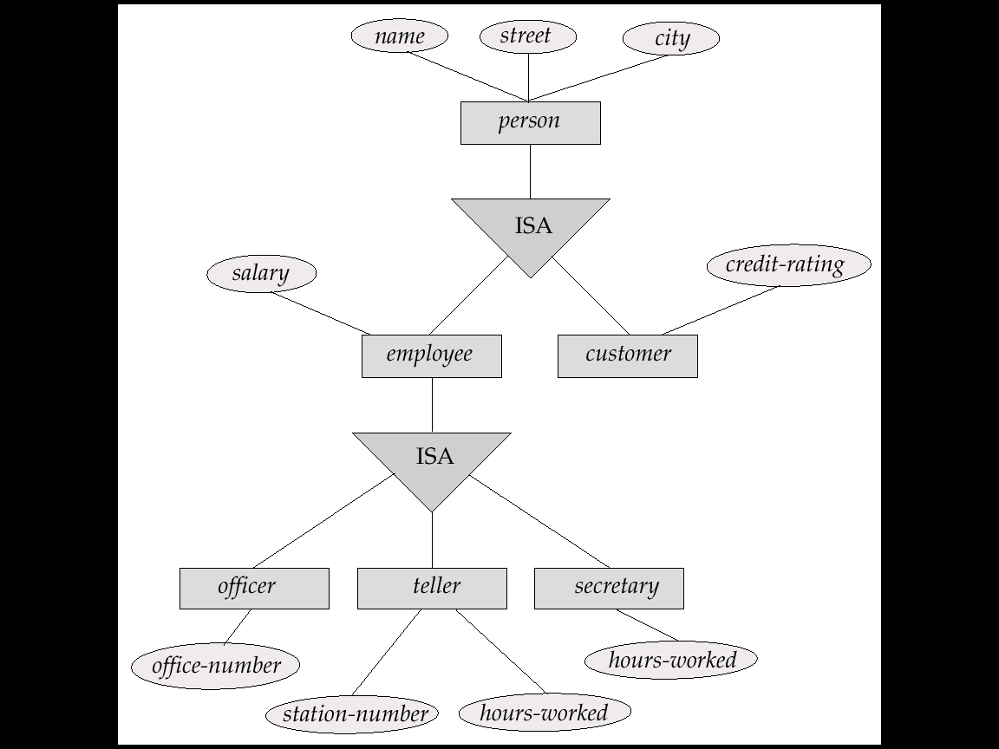

Generalization

The refinement from an initial entity set into successive levels of entity subgroupings represents a top-down design process in which distinctions are made explicit. Clearly we can form a generic entity type from sub types. Generalization and Specializations are inverse to one another.

The other examples are:

The entity Employee may be generated from two sub entity types (or sub types) called Part-time Employee and Full-Time Employee.
The entity Patient may be generated from two sub entity types (or sub types) called Inpatient and Outpatient.
The superclass entity type is also referred to as Higher level entity form (Ex. Employee)
The subclass entity type is reffered to as Lower level entity form (Ex. Teller, secretary and officer).

Constraints

Certain Constraints may be imposed on the extended E-R models. They are:

- Completeness Constraint
- Disjointness Constraint

Completeness Constraint is further divided into 2 constraints:

Total Specialization: It means that each of the super type or higher form entity must any one of the sub type entity sets or lower forms.
For example, an Employee may be either the part-time or full-time, nothing beyond the scope.

Partial Specialization: It means that each super type or higher form entity may not belong to any lower level entity sets.
For example, suppose a vehicle is defined as super class and car and bus are as the sub types. Now any vehicle may be either the car or bus and even it can be a cab.

Disjointness Constraint also further has two constraints:

Disjoint Rule: It requires that an entity belong to no more than one lower level entity set. For example, an account type may be either savings or current but not both.
Overlapping Rule: It requires that an entity may belong to more than one lower level entity set within a single generalization. For example, a Person may be both employee and customer as well.

Attribute Inheritance

A crucial property of the higher level and lower level entities created by specialization and generalization is attibute inheritance. The attributes of higher level or super type are said to be inherited by lower level entity sets. For example, customer and employee inherit the attributes of Person.

3.5 Aggregation

One limitation of E-R model is that it cannot express relationships among relationships. The best solution for this is to use aggregation. Aggregation is abstraction through which relationships are treated as higher-level entities. Observe the following examples:

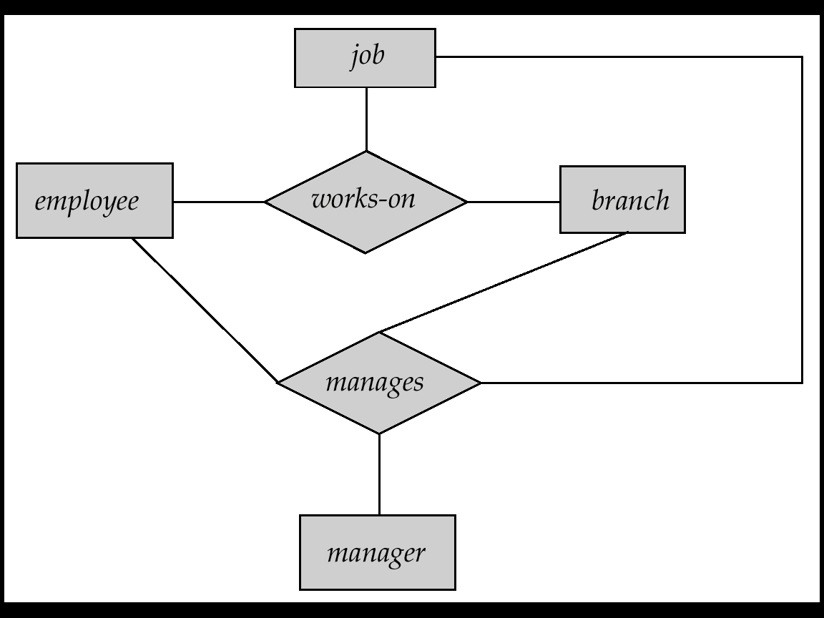

E-R diagram with redundant Relationships

We can eliminate this redundancy through aggregation. Observe the following diagram:
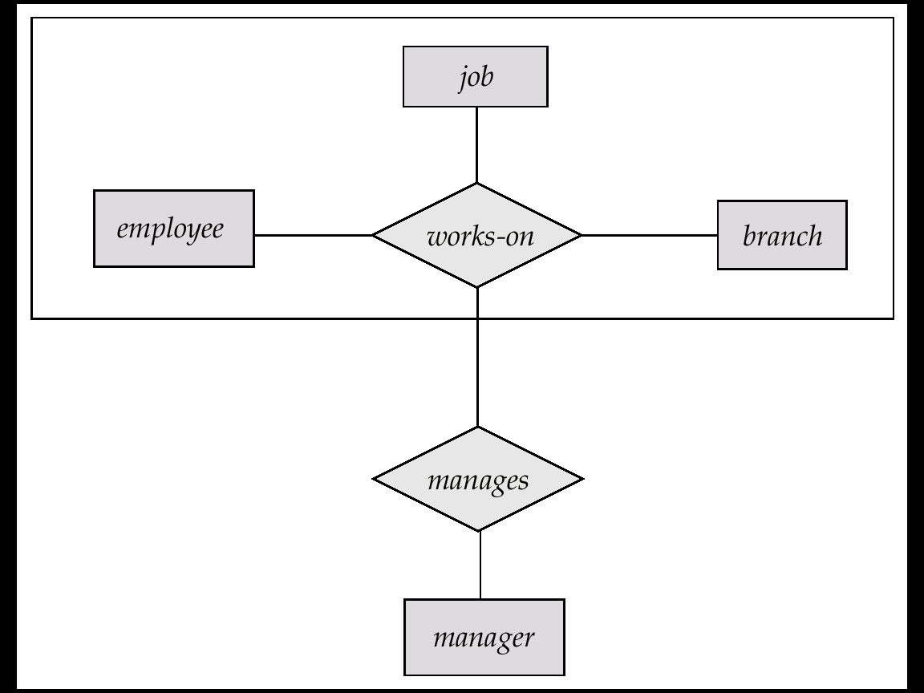

E-R Diagram with Aggregation

Summary of Symbols to be used:

